Joan Estepan

CS-360 Project One

November 13, 2022

The app I selected for this project is the Weight Tracking App, option 3. The goal of this project is to have an app that tracks the user's weight. To achieve this, we will need to have a database to store all of our users' data such as login info, weight, and goal weight. At first, there should be a login screen where users can create a new account or login into an existing one. New users, should be prompted to set their goal weight when they first use the app, however, they will be able to adjust it anytime. There should be a user-friendly home screen where it shows the user’s weight input as well as their past weight, I believe a trend graph would be a nice way to present this data to the user since they would be able to see their product visually. On the home screen, there must be a button to add a daily weight and a configuration button where we can set the weight goal and edit the login credentials. When the user reaches the goal weight a notification will be sent to the phone of the user to celebrate the achievement.

We can compare this app to Samsung Health and MyFitnessPal. Even though both of these apps contain more features, they both are weight-tracking apps at their core. Samsung health weight tracking tab is called body composition and it tracks your weight as well as BMI. The weight data shows in a trend graph which is a nice touch and will also be used in our app. If given there is enough time, the BMI calculator is one feature that I would like to implement in the app even though is not a requirement. My fitness pal is very similar to Samsung health, their weight tracking is on the bottom of the home screen, and it also uses a trend graph system to show the weight data.

We can easily identify three potential users for this application. The first type would be fitness enthusiasts, even though some people into fitness do not believe in weighting themselves often, there is plenty that does and will set a weight goal when cutting or bulking. This app would be perfect for them to keep track of their goal. Next up would be people on a weight loss journey, though not necessarily fitness enthusiasts’ people that just want to get ready for bikini season or lose weight for any health reason would benefit from this app. And lastly, people who just want to track their weight in general, whether it’s because of health reasons or simply aesthetics. Users will not need a long time to engage with our app since the weight can be updated in a few minutes.

The design for our login screen should be quite simple, just the logo on the top of the screen, username/password boxes and prompts, and a create an account link which when hit will prompt the user to enter a name, email, and password, and lastly a forgot your password link right below the password box. The main screen will have our logo or name of the app on the top left of the screen, followed by a small settings button on the top right of the screen. Then it will have a title “My Entries” and a trend graph with the data entries from the user, when we click any entry data point from this graph it will display the entry weight data at the bottom of the graph. Underneath the graph, there will be a section where it will show our current weight, the goal weight, and how many pounds there are left for the user to reach their goal. Lastly, at the bottom of the screen, there will be a long centered button to add a new weight entry.

I have designed the following sketch to have a better idea of the design:

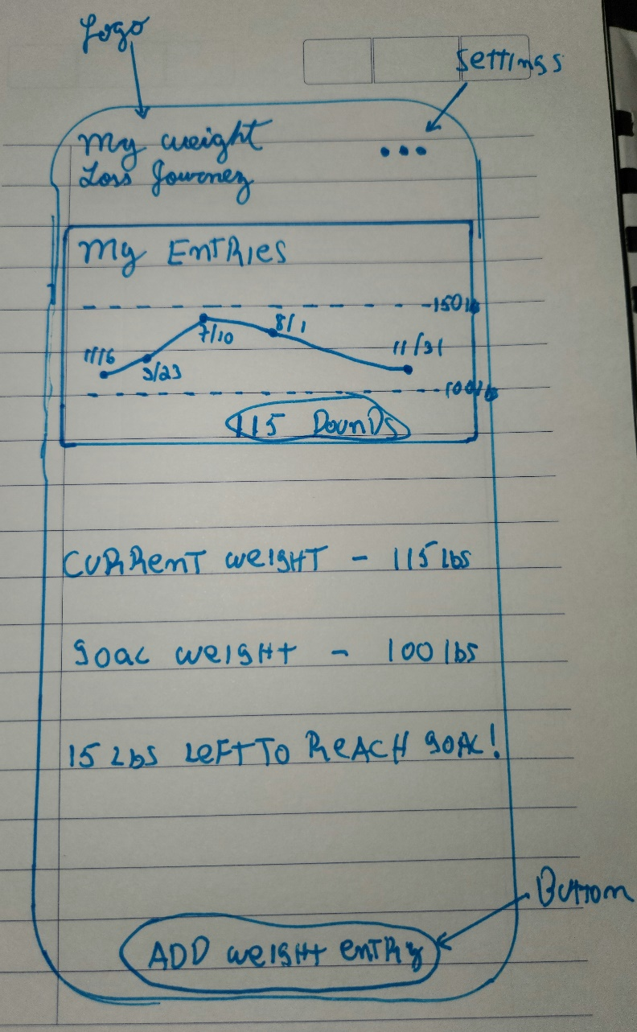

This app is going to record personal health data such as weight information, it should follow the health Connect guidelines from this week's resources. The app should pass privacy and security verification to be able to read/write to health connect. Health Connect is an API and platform, that unifies data from multiple devices into the ecosystem. Even though our app will not be connected to Health Connect in this course, it would be a good practice to follow their guidelines from the beginning, so we have the option to connect to health connect eventually.